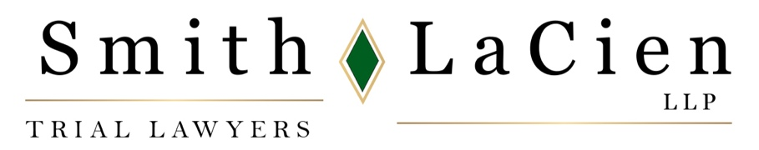

News Release

Brian LaCien Recognized as Illinois Lawyer of the Year
By 2024 Best Lawyers of America®

CHICAGO, August 17, 2023 – Brian LaCien, a founding partner of Smith LaCien LLP, has been selected as Lawyer of the Year – Aviation in the Chicago metro area and will be included in the 2024 edition of The Best Lawyers in America®, a premier attorney rating guide.

This is the second consecutive year that LaCien was selected as a Best Lawyer. Since it was first published in 1983, Best Lawyers has become universally regarded as the definitive guide to legal excellence in over 75 countries including the U.S. Inclusion is a significant achievement for those who are recognized.

LaCien has served in a leadership capacity in numerous national, regional and local lawyer organizations. He was selected by the Board of Managers of the Illinois Trial Lawyers Association (ITLA) to serve on the Association for Justice (AAJ) Board of Governors where he serves on four committees.

In June 2023, he was reappointed to Bench and Bar Section Council and appointed to the Standing Committee on Continuing Legal Education. In 2022, he was named by Lawdragon Press as a 2022 Law Dragon 500 Leading Lawyers in America. And, he has been recognized by Leading Lawyers magazine annually since 2014.

Smith LaCien LLP concentrates on serious personal injury, medical malpractice, wrongful death, trucking litigation, birth injuries, and mass torts. The firm has a lengthy track record of achieving exceptional results for clients, with more than $2 billion in verdicts and settlements, and over 100 cases with results of at least $1 million.

Smith LaCien LLP is located at 70 W. Madison, Suite 2250, Chicago, IL 60602; website www.smithlacien.com, phone (312) 509-8900, email: info@smithlacien.com. For more information, contact Chris Ruys, chris@chrisruys.com, 312-337-7746 (office), or 312-259-3495 (mobile).

# # #

