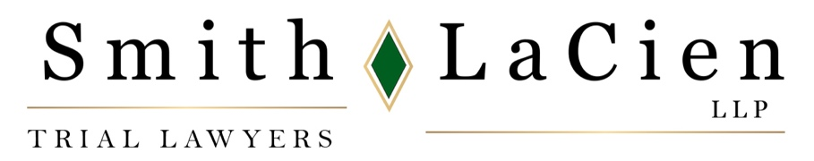

News Release

Smith LaCien Trial Lawyers Recognized as 2024 Best Lawyers®

CHICAGO, August 17, 2023 – Five attorneys from Smith LaCien LLP have been selected for inclusion in the 2024 Chicago metro edition of The Best Lawyers in America®, a premier attorney rating guide.

They are founding partners Todd A. Smith and Brian LaCien, and attorney Carla A. Colaianni. Named as Best Lawyers in America® “Ones to Watch” are Andrew M. Mason and Allyson C. Cox. LaCien was named Illinois “Lawyer of the Year” in the aviation category.

Smith has been a Best Lawyer since 1997. He has won its “Lawyer of the Year” award in recognition of the highest overall peer feedback in Injury law in Illinois. He was also recognized for his Product Liability Litigation experience and for his work in Medical Malpractice Law. LaCien was named as a 2024 “Lawyer of the Year” in the aviation category.

This is the second consecutive year that LaCien was elected as a Best Lawyer and the first year for Colaianni. Mason and Cox are included in the Best Lawyers: Ones to Watch in America™ category, which recognizes top attorneys who have been in practice for less than 10 years.

Since it was first published in 1983, Best Lawyers has become universally regarded as the definitive guide to legal excellence in over 75 countries including the U.S. Inclusion is a significant achievement for those who are recognized.

Smith LaCien LLP concentrates on serious personal injury, medical malpractice, wrongful death, trucking litigation, birth injuries, and mass torts. The firm has a lengthy track record of achieving exceptional results for clients, with more than $2 billion in verdicts and settlements, and over 100 cases with results of at least $1 million.

Smith LaCien LLP is located at 70 W. Madison, Suite 2250, Chicago, IL 60602; website www.smithlacien.com, phone (312) 509-8900, email: info@smithlacien.com. For more information, contact Chris Ruys, chris@chrisruys.com, 312-337-7746 (office), or 312-259-3495 (mobile).

# # #

